The Switch
Instructions

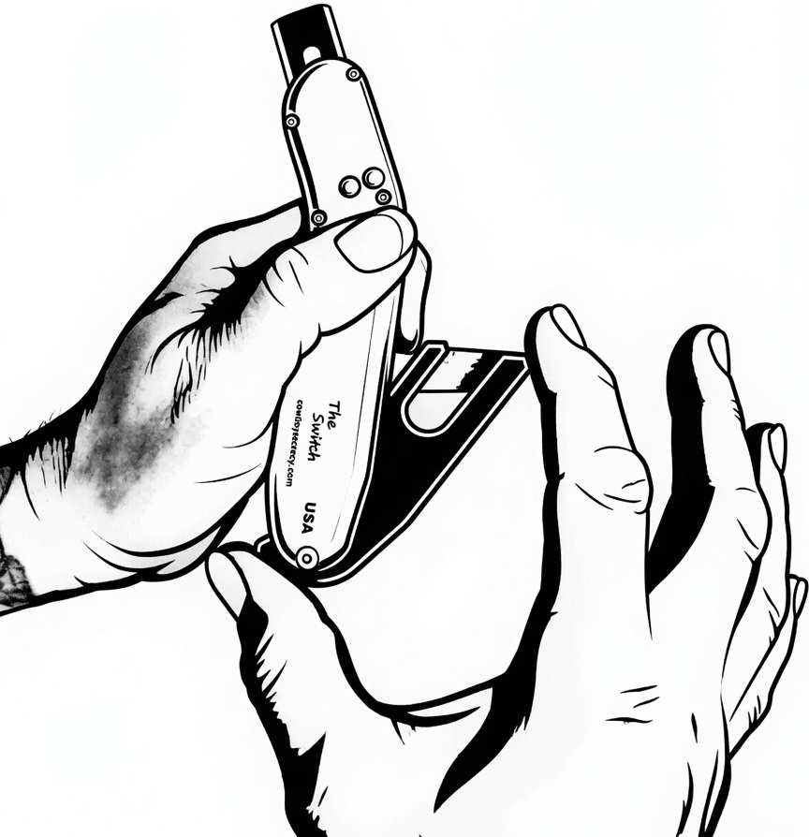
Step 1:
While holding the knife in your left hand. Use your right thumb to push in tab at the bottom of bin case to the left and upward at the same time “Clock Wise Motion”. Then hook your right index finger onto top of bin case tip to hold open the knifes blade case.

Step 2:
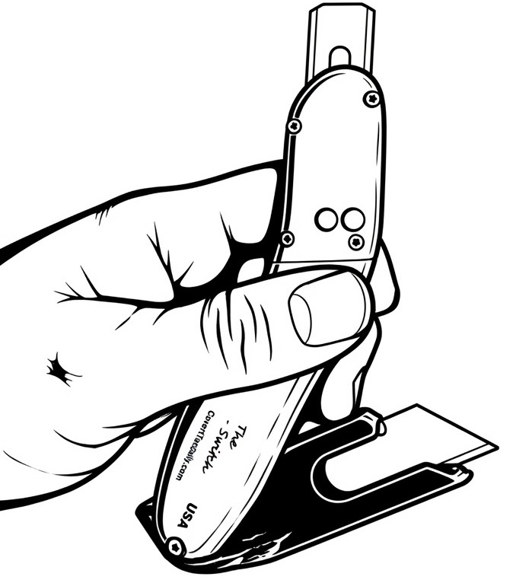
At this point while holding the knife firmly between your left hands thumb and right hands index finger. Put your left hands middle finger in between the bin case and knife body. Be aware the bin case will automatically retract, so don’t let go during this process, this allows you to use your right hand freely to unload and reload razor blades. Warning: before removing middle finger to retract bin case, make sure razor blades are not sticking out of bin case opening before allowing the bin case to retract closed. Always make sure you load Utility Blades or Hook Blades as pictured in step two.

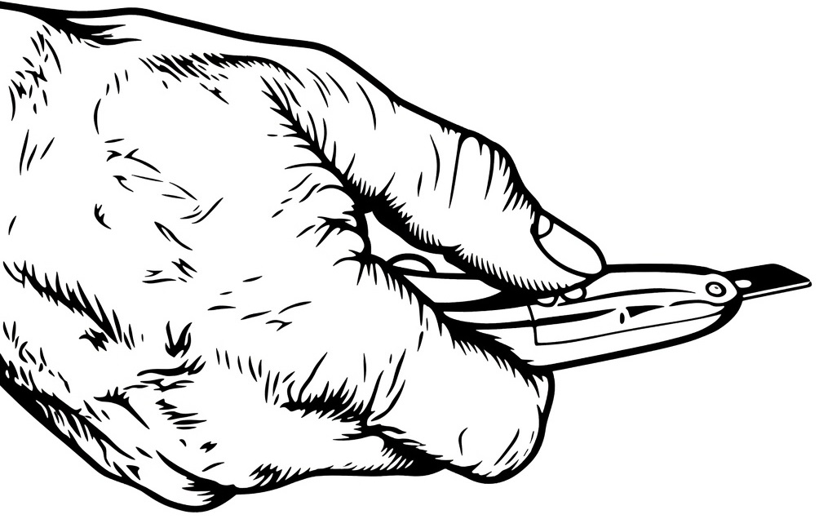
Step 3:
To remove and replace any types of blades, always push both buttons at the same time with your thumb, then gently slide them in or out making sure to not touch the sharp edges of the blades while doing the blade change process. Always make sure the Bin Case is closed during this blade changing process.

